1. **Experiment:** Software structure prediction and visual inspection
2. **Time:** 2024.06.07-2024.06.15
3. **Member:** Xudong Tang, Yang Jin, Binxuan Zhang, Xuantong Liu, Kaiqing Zhang
4. **Method:**
5. Alphafold3 structure prediction
6. Open the website, find an interface for inputting the protein sequence. Select "protein" for all options, and then input data.
7. Initially, input IL-2Rβ sequence and IL-2Rγ sequence. These two sequences are always consistent and no need to be changed in subsequent steps.
8. For the third entry, input our predicted protein structure: β + linker + γ. Through sequencing, we selected three complexes B34G35R-G, B51G35R-G, and B51G9-G, and chose GALA peptide which repeat four to six times as linker to connect protein fragments. Through arranging and combining them, we got 9 combinations.
9. Evaluate the predicted protein structures through scores and predicted 3D model.
10. Visual inspection
11. Notably, we use the candidate sequences, specifically B34, and 51, along with G9 and 35. These sequences were truncated to retain the 20 amino acids implicated in binding interface contacts, with the exception of β34, which was truncated to 39 amino acids for further investigation.
12. In PyMOL chains should be renamed. Then, hydrogen bonds are found by clicking "find-polar-contacts-to other atoms in object". The stick structures of the protein molecules are displayed. After the amino acids connected by hydrogen bonds are clicked, we show the cartoon figure of the molecules and show the stick structure of the amino acids clicked. Then, the sequence numbers and names of the amino acids can be annotated by clicking on "label-residue".
13. Click " draw/ray-save image to file "
14. **Result:**

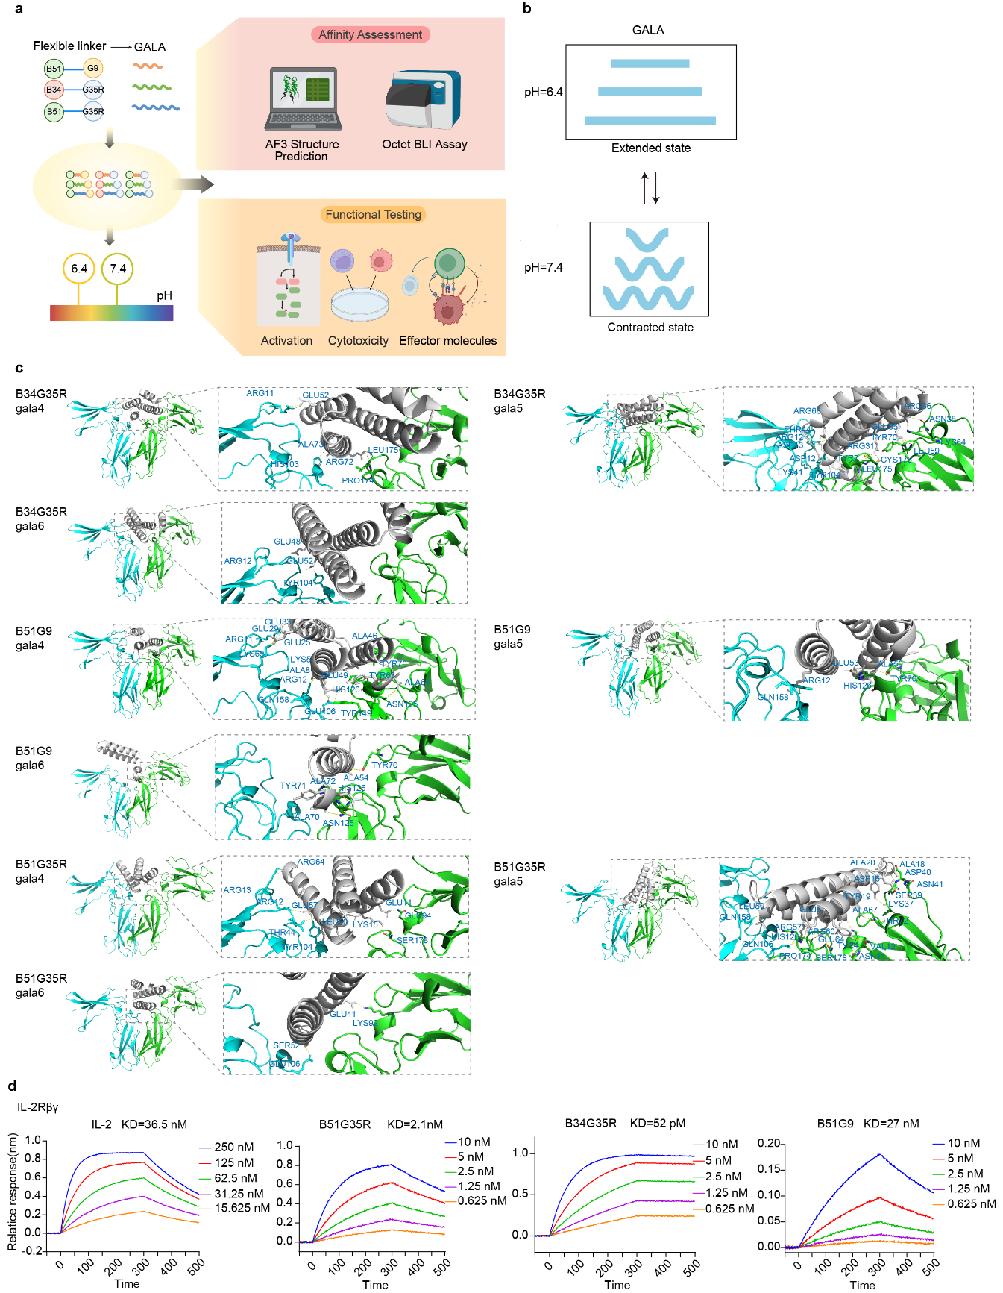

**Fig.1** The front view of the binding sites between 9 sequences with IL-2Rβγ, with the box zooming in to show the amino acids at the binding site (stick representation).

**Table.1** The Specific Sequences of Nine Candidates

|  |  |
| --- | --- |
| Name | Sequences |
| B34G35-GALA4 | TAAERKYLAAQDDPEAAAAWLAEIAAIEAERTAAERAWA GGGSEALAEALAEALAEALAGGGSRAAAELAERLARAALLAALR |
| B34G35-GALA5 | TAAERKYLAAQDDPEAAAAWLAEIAAIEAERTAAERAWA GGGSEALAEALAEALAEALAEALAGGGSRAAAELAERLARAALLAALR |
| B34G35-GALA6 | TAAERKYLAAQDDPEAAAAWLAEIAAIEAERTAAERAWA GGGSEALAEALAEALAEALAEALAEALAGGGSRAAAELAERLARAALLAALR |
| B51G35-GALA4 | AAEYEYALAKELAAKDPAYA  GGGSEALAEALAEALAEALAGGGS RAAAELAERLARAALLAALR |
| B51G35-GALA5 | AAEYEYALAKELAAKDPAYA  GGGSEALAEALAEALAEALAEALAGGGS RAAAELAERLARAALLAALR |
| B51G35-GALA6 | AAEYEYALAKELAAKDPAYA  GGGSEALAEALAEALAEALAEALAEALAGGGSRAAAELAERLARAALLAALR |
| B51G9-GALA4 | AAEYEYALAKELAAKDPAYA GGGSEALAEALAEALAEALAGGGSKEAAKALATALRLAGTRLFT |
| B51G9-GALA5 | AAEYEYALAKELAAKDPAYA GGGSEALAEALAEALAEALAEALAGGGSKEAAKALATALRLAGTRLFT |
| B51G9-GALA6 | AAEYEYALAKELAAKDPAYA GGGSEALAEALAEALAEALAEALAEALAGGGSKEAAKALATALRLAGTRLFT |